DR600-A
All-Scenario Drone Detection and Positioning Device

Technical Specifications

Table of Contents
1. Introduction 3
2. Device Overview 3
2.1 Device Name 3
2.2 Device Model 3
2.3 Device Usage 3
2.4 Device Technical Parameters 4
3. Device Features and Functions 5
4. Device Structure and Components 5
4.1 Device Six Views 6
4.2 Device List 6
5.Device Control and Interface 7
5.1 Device Operation Interface 7
5.2 Device Security Protection 9
6. Device Maintenance 9

1. Introduction
With the rapid development and popularization of drone technology, drones have shown great application potential in aerial photography, agriculture, rescue, security and other fields, but at the same time they have also brought increasingly serious safety risks. Incidents such as illegal intrusions, malicious reconnaissance, and privacy violations occur frequently, posing serious threats to national security, public safety, and personal privacy. Therefore, the development of efficient and advanced drone jamming technology has become an urgent need to maintain airspace security and ensure social stability.

2. Device Overview
All-scenario drone detection and positioning device integrates full-frequency detection, drone and pilot positioning, FPV video capture and storage. It is capable of accurately identifying quadcopters, fixed-wing drones, DIY drones, and FPV drones even in complex electromagnetic environments, and provides sound, light, and vibration alerts. It is mainly used for routine patrols, critical asset protection, team-based operations, and investigative evidence collection.

2.1 Device Name
DR600-A all-scenario drone detection and positioning device

2.2 Device Model
DR600-A

2.3 Device Usage
Incidents such as illegal intrusions, malicious reconnaissance, and privacy violations occur frequently through drones, posing a serious threat to national security, public safety, and personal privacy. Therefore, the development of efficient and portable drone countermeasures technology has become an urgent need to maintain airspace security and ensure social stability.

2.4 Device Technical Parameters
Number | Name | Specifications
 | Identification types | Supports mainstream drones such as DJI, Autel, Hubsan, as well as FPV racing drones and DIY drones
 | Frequency range | Supports customizable scanning from 70 MHz to 6.2 GHz.  Default detection bands: 400 MHz, 800 MHz, 900 MHz, 1.2 GHz, 1.4 GHz, 2.4 GHz, 5.2 GHz, 5.8 GHz (other bands can be customized)
 | Positioning models | Full range of DJI drones, selected models from Autel
 | Detection range | ≥10 km for mainstream drones, ≥2 km for FPV drones
 | DID/RID positioning range | DID≥10km，RID≥3km
 | Positioning accuracy | ≤10 m
 | FPV video signal detection | Supports analog video transmission detection within the 500 MHz – 6 GHz band (customizable)
 | Detection radius | ≥1.5 km (line-of-sight, clean electromagnetic environment)
 | Video capture distance | ≥1.5 km (line-of-sight, clean electromagnetic environment)
 | Detection response time | ≤3 s (8 frequency bands); ≤5 s (12 frequency bands)
 | Power supply | Lithium battery powered
 | Battery life | ≥6 hours (main unit)
 | Device weight | ≤8 kg
 | Device dimensions | 343 mm × 230 mm × 86 mm (L × W × H)

- Device Features and Functions
Full-Band Detection: 70 MHz to 6.2 GHz wide-spectrum scanning
Analytical Positioning: Monitors multidimensional data such as drone location (latitude, longitude, azimuth), speed, flight path, and controller position (latitude, longitude, azimuth)
FPV Video Capture: Captures all analog video transmissions, enabling first-person view analysis of FPV intrusions and real-time dynamics
Enhanced Detection Capability: Detection and decryption range up to 12 km
Multi-Terminal Alarm Push: Alarm information pushed to multiple mobile terminals for team collaboration and efficient response
Multi-Scenario Deployment: Supports backpack-mounted, fixed-site, and vehicle-mounted operations

4. Device Structure and Components
The DR400D (plus) all-scenario drone detection and positioning device consists of four antenna units, a radio detection module, a video capture module, a PC terminal, a main housing, a power supply unit, and a backpack.

4.1 Device Six Views
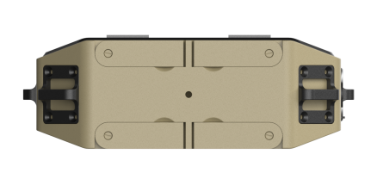 | 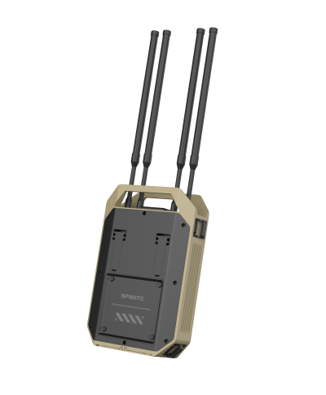
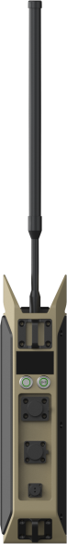 | 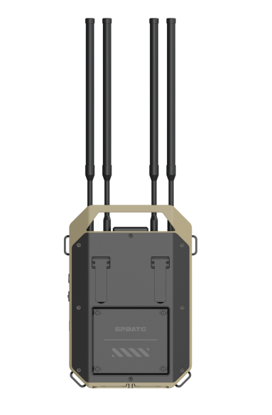
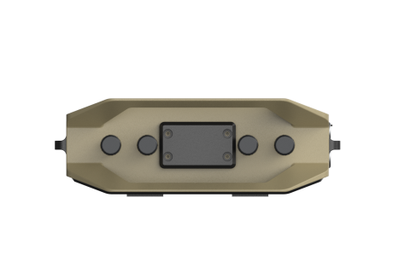 | 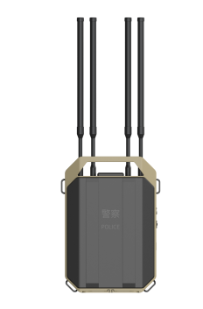

4.2 Device List
Serial number | Product name | Product picture | Number | Size  (mm) | Weight (kg)
1 | Main device | 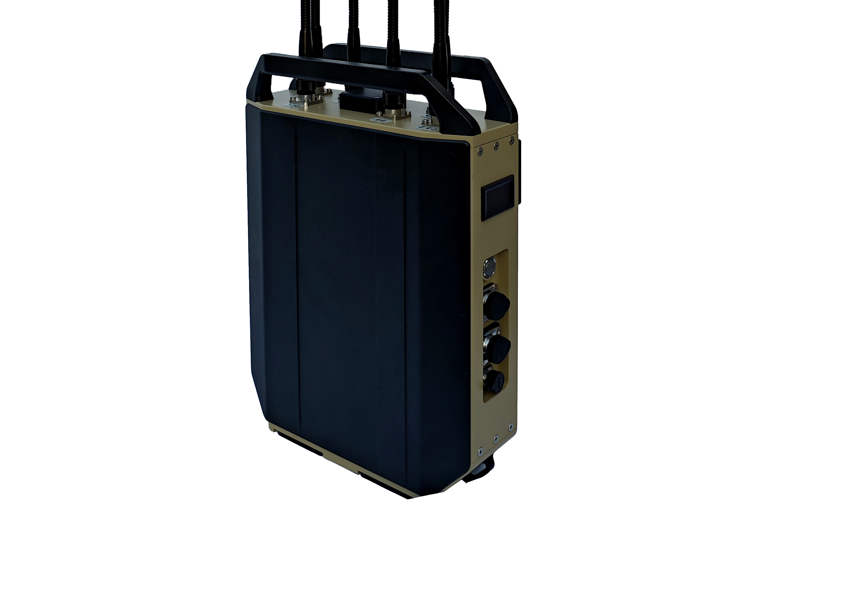 | 1 | 400mm * 165mm * 500mm | 7.25
2 | Antenna | / | 6 | Diameter 16 mm * height 400mm | 0.9
3 | Charger | 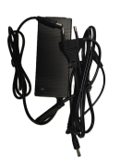 | 1 | / | 0.25
4 | Backpack |  | 1 | 337mm * 475mm | 0.65
5 | Aviation case | 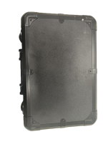 | 1 | 550mm*400mm*240mm | 3.8

5.Device Control and Interface
Product Interface Definitions:
- Power Supply Interface: 2-pin power cable (12V)
- Internet Interface: RJ45
- Data Interface: Type-C

5.1 Device Operation Interface

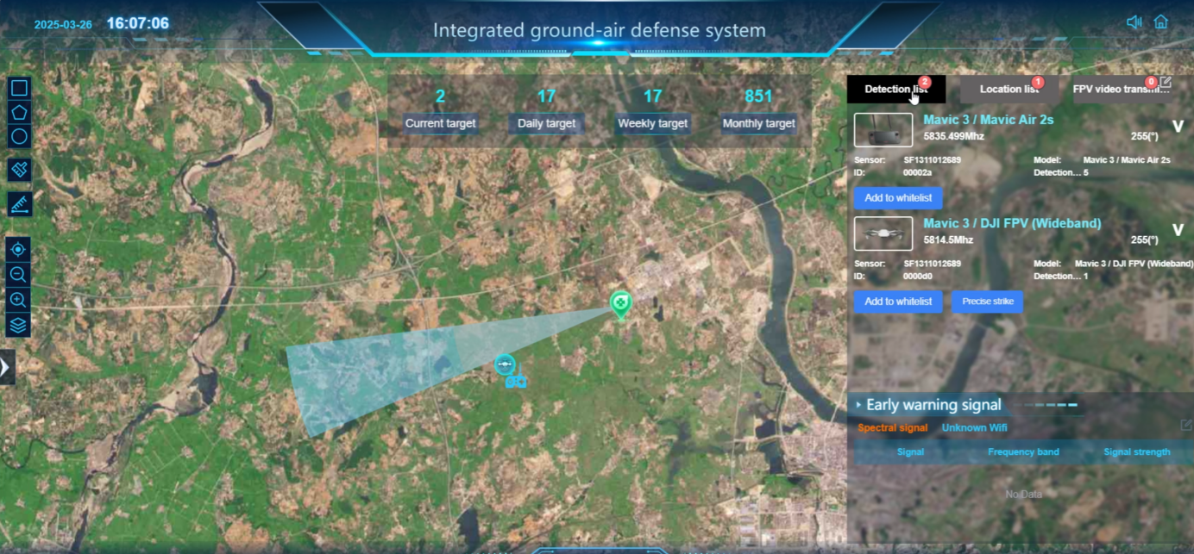
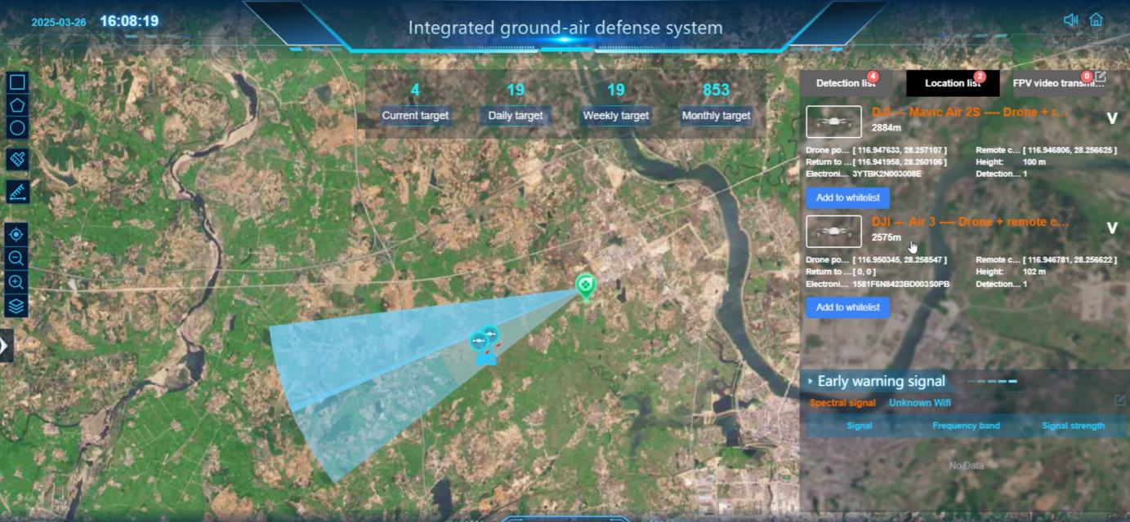
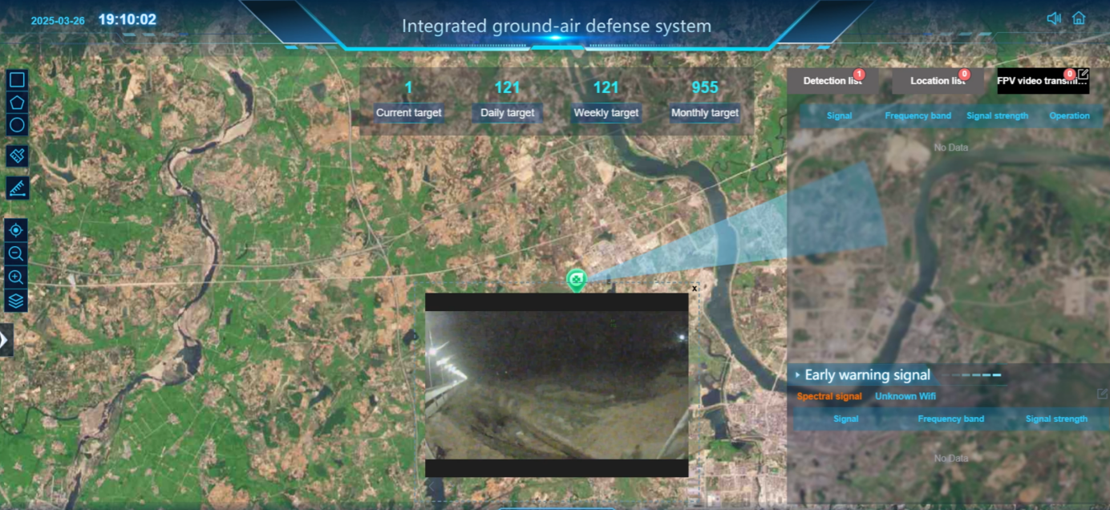

5.2 Device Security Protection
Packaging size: Length 500mm* Width 200mm* Height 500mm

6. Device Maintenance
Power on the device regularly to check its status.

